Experiment-10

**Aim:** Hands-on experimentation of interfacing stepper motor with ATMega32 programming in C .

**Objectives:** After successfully completion of this experiment students will be able to,

* Use C language for ATMega32 microcontroller programming on AVRStudio.
* Experiment with Stepper motor interfacing with ATMega32 on ATMega32 AVR Development Board.

# Equipment required:

* Windows7 or later based host computer
* ATMega32 Development board
* USBasp Programmer
* Jumper Wires
* Stepper Motor

# Software required:

* AVR Studio7 installation setup
* USBasp driver installation setup

# Theory:

**Basics of Stepper Motor**

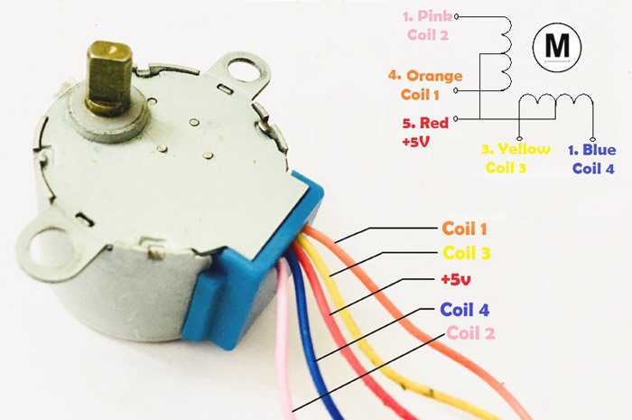

**Stepper Motor**

Stepper Motors are DC brushless motors which can rotate from 00 to 3600 in steps. Stepper motor uses electronic signals to rotate the motor in steps and each signal rotates the shaft in fixed increment (one step). The rotation angel is controlled by applying certain sequence of signals. Unlike Servo Motor, stepper motors can be driven by using GPIO pins of microcontroller rather than PWM pins and can rotate in (+3600) and (-3600). The order of signals decides the clockwise and counter clockwise direction of stepper motor. To control the speed of the motor, we just need to change the rate of control signals applied. The stepper motors rotates in steps. There are several modes of steps to operate Stepper Motor such as full step, half step and microstep.

Enough of boring theory, let’s assume someone gives you a stepper motor say the famous 28-BYJ48 and you are really curious to make it work. By this time you would have understood that it is not possible to make these motors rotate by just powering them through a supply, so how would you do it?

Okay, so unlike a normal DC motor this one has five wires of all fancy colors coming out of it and why is it so? To understand this we should first know how a stepper which we already discussed. First of all **steppers motors do not rotate**, they step and so they also known as **step motors**. Meaning, they will move only one step at a time. These motors have a sequence of coils present in them and these coils have to be energized in a particular fashion to make the motor rotate. When each coil is being energized the motor takes a step and a sequence of energization will make the motor take continuous steps, thus making it to rotate. Let us take a look at the coils present inside the motor to know exactly know from where these wires come from.

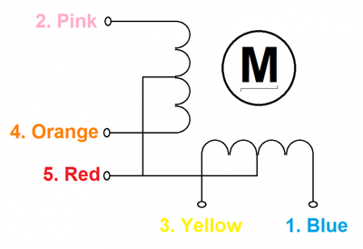

As you can see the motor has **unipolar 5-lead coil arrangement**. There are four coils which have to be energized in a particular sequence. The Red wires will be supplied with +5V and the remaining four wires will be pulled to ground for triggering the respective coil. We use any microcontroller to energize these coils in a particular sequence and make the motor perform the required number of steps. Again there are many sequence you can use, normally a *4-step* is used and for more precise control an *8-step* control can also be used. The sequence table for 4-step control is shown below.

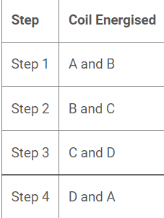

### Why do we need Driver modules for Stepper Motors?

Most **stepper motors** will operate only with the help of a driver module. This is because the controller module (Microcontroller/Digital circuit) will not be able to provide enough current from its I/O pins for the motor to operate. So we will use an external module like **ULN2003** module as **stepper motor driver**. There are a many types of driver module and the rating of one will change based on the type of motor used. The primary principle for all driver modules will be to source/sink enough current for the motor to operate.

**INTERFACING DIAGRAM**

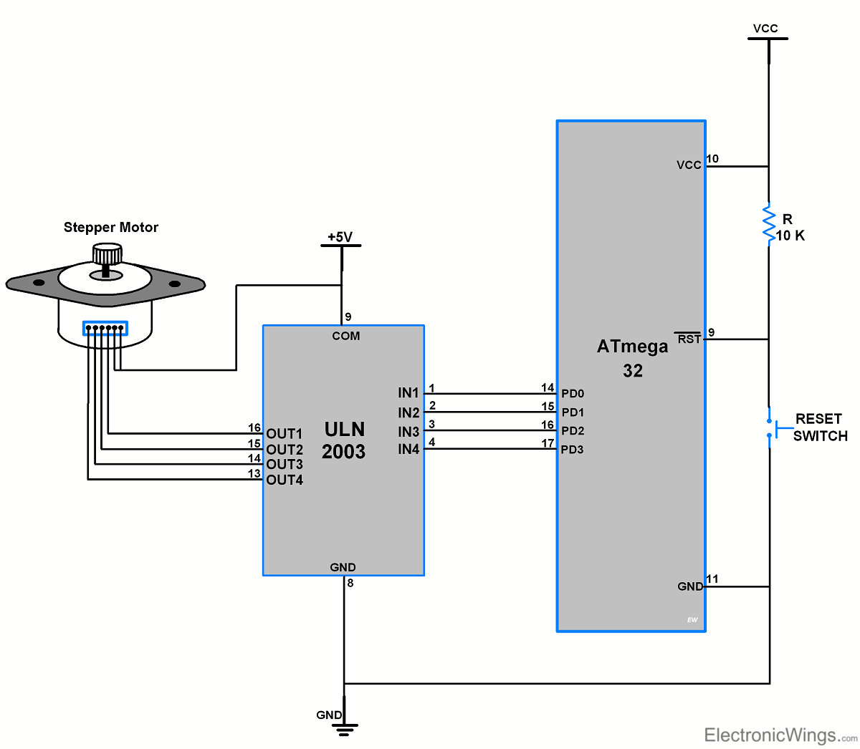

* Here we are going to interface 6 wires Unipolar Stepper Motor with ATmega32 controller.
* Only four wires are required to control the stepper motor.
* Two common wires of stepper motor connected to 5V supply.
* ULN2003 driver is used to the driving stepper motor.
* Note that to know winding coil and their center tap leads measure resistance in between leads. From center leads, we will get half the resistance value of that winding.

**CODE:**

#define F_CPU 8000000UL

#include <avr/io.h>

#include <util/delay.h>

int main(void)

{

int period;

DDRD = 0x0F;

period = 100;

while (1)

{

for(int i=0;i<12;i++)

{

PORTD = 0x09;

_delay_ms(period);

PORTD = 0x08;

_delay_ms(period);

PORTD = 0x0C;

_delay_ms(period);

PORTD = 0x04;

_delay_ms(period);

PORTD = 0x06;

_delay_ms(period);

PORTD = 0x02;

_delay_ms(period);

PORTD = 0x03;

_delay_ms(period);

PORTD = 0x01;

_delay_ms(period);

}

PORTD = 0x09;

_delay_ms(period);

_delay_ms(1000);

for(int i=0;i<12;i++)

{

PORTD = 0x09;

_delay_ms(period);

PORTD = 0x03;

_delay_ms(period);

PORTD = 0x06;

_delay_ms(period);

PORTD = 0x0C;

_delay_ms(period);

}

PORTD = 0x09;

_delay_ms(period);

_delay_ms(1000);

}

}

**OUTPUT:**

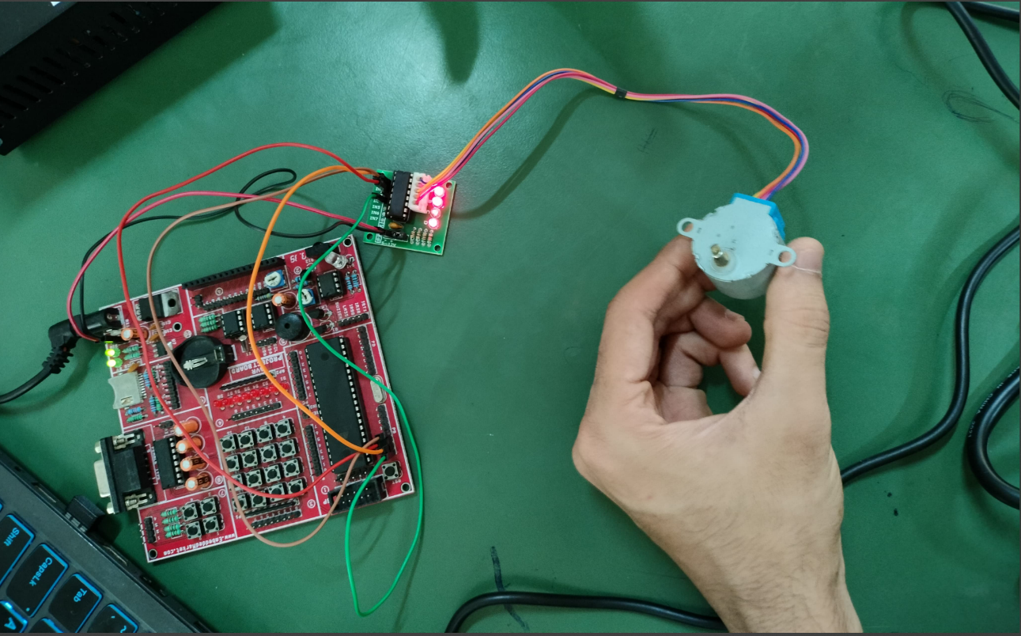

**CONCLUSION:**

By Performing this experiment I came to know about the interfacing of Stepper motor with ATMega32.

**Experiment-12 Post Lab Exercise**

Student Name: Aryan Langhanoja

Enrollment No: 92200133030

**Answer the following questions:**

1. What is the name of the Driver used in this experiment?

* The name of the driver commonly used for controlling stepper motors with an AVR ATMega32 is the ULN2003A or L298N driver.

1. True or False. I can rotate the stepper motor

* True. You can rotate a stepper motor using an AVR ATMega32 microcontroller by providing appropriate control signals to the stepper motor driver.

1. In stepper motor, what do we mean by full step sequence and half step sequence?

* Full step sequence: In a full step sequence, each step corresponds to energizing one coil at a time. This sequence provides relatively higher torque but lower resolution compared to half step sequence.
* Half step sequence: In a half step sequence, each step alternates between energizing one coil and two coils simultaneously. This sequence provides higher resolution but lower torque compared to full step sequence.

1. How many coils are present in the stepper motor?

* Stepper motors typically have two or more coils. Common stepper motors have either 4, 5, 6, or 8 coils.

1. What kind of applications are there for using the stepper motor in the microcontroller project?

* Stepper motors are commonly used in microcontroller projects for precise positioning and motion control. Some applications include:
* CNC machines (for controlling the movement of axes)
* 3D printers (for controlling the movement of print head and build platform)
* Robotics (for controlling the movement of robotic arms and joints)
* Automated systems (for precise control of conveyor belts, cameras, etc.)
* Scanners and plotters